Krishi Evam Shaikshik Prabandha Sansthan
Sultanpur U.P. 228001

Our Innovations:

- Kisan Vidyalaya (farmers field school)
- Bio park (An Unit for the production of bio compost)
- PROCESS USED TO ACHIEVE Sustainable self help groups
- Strategy to Overcome the Problems in a Sustainable Manner
- The AEMI has Envisioned To Make The Project Sustainable Ensuring the Farmers Self Reliant
- Women Agriculture Extension Programme
- An Innovative Model of Self Sustained Extension Work
- Participatory Rural Appraisal (PRA) Based Innovations
- Establishment of Village Resource Centre

- Kisan Vidyalaya (farmers field school)

First in India, established innovative concept of farmer to farmer extension services to make the farmers self reliant for the dissemination of technology , assured and quality input supply, community & credit mobilization, diversification, reduction in cost of cultivation, marketing of the produce and also for the quality production.
The innovative model named as Shahabhagi Krishi Prasar Kisan Vidyalaya- Narangpur-Patti, Pratapgarh . This Vidyalay was established in the year 1998 by the farmers, of the farmers and for the farmers . This model is appreciated by the delegates of different countries of the world during their visits. This is accepted and replicated by several W.B. financed project in u.p. , Nearly 1400 farmers field school have been established in U.P. This is the success of the same model. The govt. of u.p. has accepted the importance of this model and issued a order to form the same Kisan Vidyalaya in all the blocks of u.p.

- Bio park (An Unit for the production of bio compost)

(A) Bio-ParK:-

This institute has promoted production and use of Bio-Compost in large scale in the district – Azamgarh, Pratapgarh, and Jaunpur.

(A) Bio-ParK:-
An innovative concept of “BIO-PARK” ( an unit for production of Bio Compost) is given by this institute which is appreciated by the W.B. vice chairman, other World Bank representatives and senior officers of U.P.

The Bio-Park has following details:-
(i.) NEED AND PROBLEM:-
    - Increasing trend of requirement of N.P.K., increasing the cost of cultivation continuously.
    - Deterioration in quality of produce.
    - Bad effect on the health due to consumption of same polluted produce.
    - Bad effect on the environment and Food-Chain. Hence danger on the survival of life.
    - Regular decrease in fertility of soil, may result conversion of land into unfertile land.
    - Imbalanced situations in physical and chemical structure of soil.
    - Decrease in no of friend insects and rational increase in no. of enemy inscts.
    - Increase in new-new infections/ diseases.
    - Maximum expenditure of income is in purchase of medicines. Keeping in view to solve above need and problems, following objectives are set to establish Bio-Park.
ii. OBJECTIVES:-
- Establishment of Bio-Park for the production of Bio-Compost.
- Increase income through production, use and selling of Bio-Compost.
- Use of bio-compost will increase the fertility of soil and decrease the requirement of chemical fertilizer by which cost of cultivation will be reduced.
- Production of quality produce.
- To increase the fertility of Soil By which increase in production and productivity.
- To conserve and clean the environment and also to maintain the Food-Chain balanced.
- To ensure the availability of vegetables, medicinal plants, fruit plants and flowers side by side .
iii. COMPONENTS OF BIO-PARK:-
1. Nadep Compost
2. Vermi Compost
3. Cow Pat Pit (C.P.P.)
4. Cow Horn manaur (CHM)
5. Tricoderma multiplication
6. Cultivation of medicinal plant and flowers.
7. Establishment of kitchen garden.
(A) Bio-ParK:-

(A) Bio-ParK:-
(A) Bio-ParK:-

3.PROCESS USED TO ACHIEVE SUSTAINABLE SELF HELP GROUPS

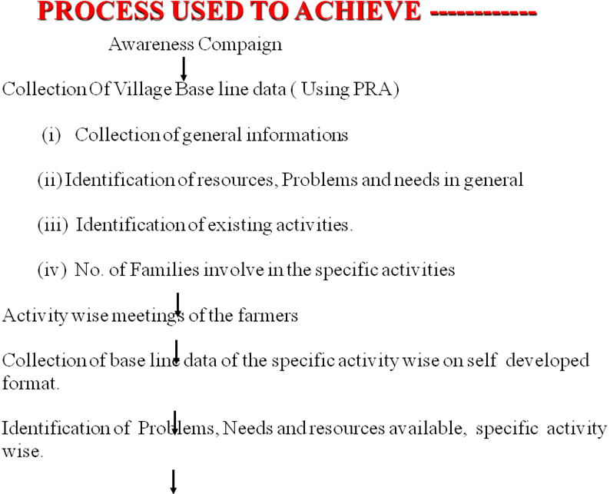

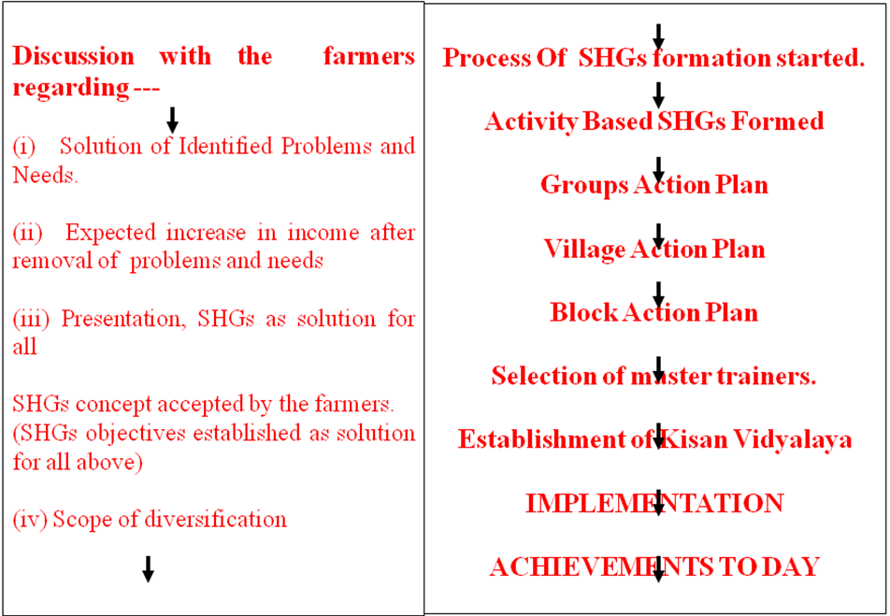

4. Strategy to Overcome the Problems in a Sustainable Manner
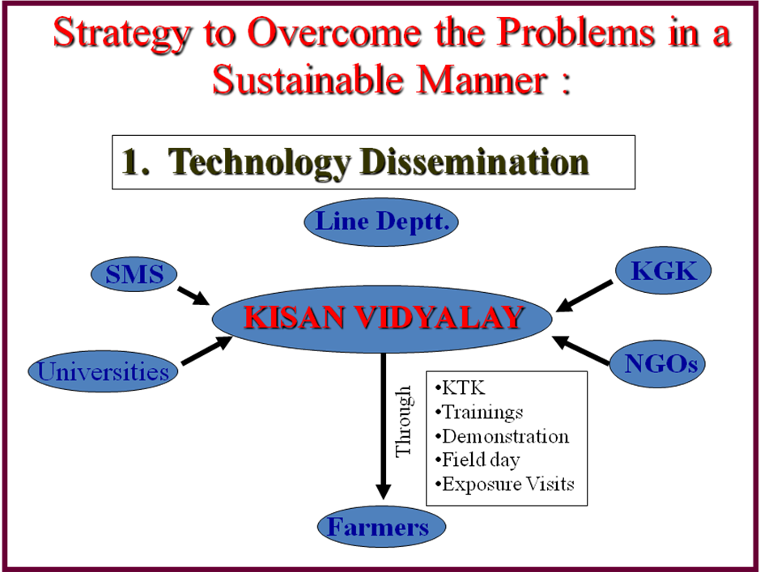

(A) Bio-ParK:-

(A) Bio-ParK:-

5
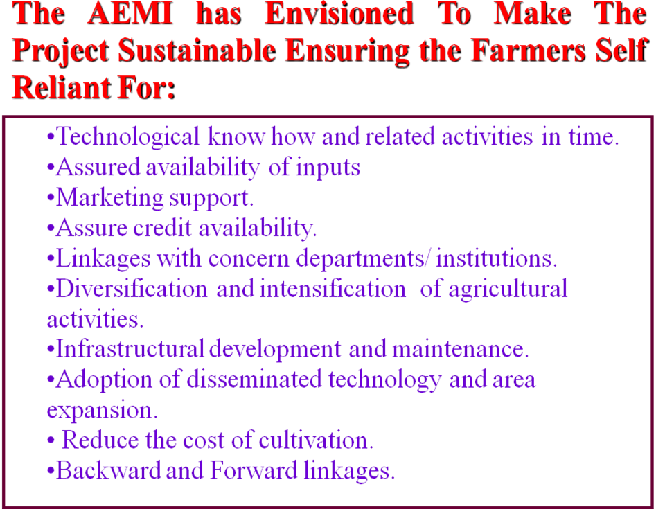
5.

- Women Agriculture Extension Programme :-
Maximum women are working within the house but not on the field. To utilize the efficiency in agricultural activities on the field, to develop the efficiency/ capacity and also to increase the income of women above women agriculture extension programme was launched in the district Jaunpur by self resources. The highlights of the programme is:-
1. 297 women came out from the house and started the agriculture field work.
  - Total area was covered under the programme is 702 hectare.
3. As cash crop vegetables, vegetable pea, maize pigeon pea are taken.
Now involved women are self- reliant for the cultivation related activities.

- An Innovative Model of Self Sustained Extension Work :-

It is widely accepted that line departments are unable to provide required extension services to the farmers due to lack of resources. There is great challenge that how extension services can be provide to the farmers in sustainable manner. This institute has developed. An innovative vision of self sustained extension work.

7. Participatory Rural Appraisal (PRA) Based Innovations:-

This institute has always used PRA exercise and SWOT analysis (Strength, Weakness, Opportunity and threaghts) as a tool in identification of need, problem, resources available, social facilities and other relevant data collection and analysis. On the basis of PRA/SWOT following innovative work have been completed with full participation of beneficiaries:

S.N. | Name of Activities | District | Project Name
1. | Strategic Research Extension and Marketing Plan | Jaunpur and Bhadohi | DASP U.P.
2. | Strategic Research Extension Plan (SREP) | Sultanpur | U.P.S.L.R.P.
3. | Site Implementation Plan (SIP) | Pratapgarh, Raibereli, and Allahabad | U.P.S.L.R.P.
4. | Village Action Plan | Jaunpur | DASP U.P.
5. | Water Users Association Action Plan (WUAAP) | Pratapgarh, Sultanpur, Jaunpur and Baharaich | UPWSRP
6. | Outlet Committee (Kulaba) Action Plan (OCAP) | Pratapgarh, Sultanpur, Jaunpur and Baharaich | UPWSRP
7. | Site Implementation Committee | Pratapgarh, Raibareli, and Allahabad | U.P.S.L.R.P.
8. | Water User Group Action Plan (WUGAP) | Pratapgarh, Raibareli, and Allahabad | U.P.S.L.R.P.
9. | Self Help Group Action Plan (SHGAP) | Pratapgarh, Juanpur, Sultanpur, Azamgarh, Banda, Balrampur, Allahabad, and Ambedkarnagar | UPSLRP, DASP U.P., SGSY, RSVY, Swashakti, WDP, Swayam Siddha U.P.

The above innovative vision have their own value and specificity in the Socio-Economic development of community. The peculiarities of these innovative vision are given below:
- The action plan have been prepared with full participation of farmers.
- In the data collection and identification of need, problem, resources and social infrastructure PRA exercise and SWOT analysis have been applied.
- Time frame schedule has been prepared for the implementation of said action plan.
- To own the activities, full participation of farmers at all level from planning, implementation, review, monitoring, evaluation to sustainability have been designed in action plan.
- Action plan are approved by the community organisation like SIC, VAC, WUA, WDC, and SHGs etc.

8. Establishment of Village Resource Centre:-
To provide the technical know how and other relevant information, assured input supply, equipment and marketing of the produce. Village Resource Centre (VRCs) have been establiehd under the UPSLRP, DASP-U.P., and RSVY. The total 26 VRCs have been established in the village. The highlights are given below:-
Highlights:-
- These VRCs are under the supervision of farmers.
- These VRCs are well furnished and having, literatures, input and equipments.
- These VRCs are more effective in the development of communities. VRCs or providing required facilities at village level to the farmers.

