Krishi Evam Shaikshik Prabandha Sansthan
Sultanpur U.P. 228001

E.Diversification and Intensification of Agricultural Activities

The agriculture and its allied activities include the followings agriculture related sub thematic area. :-----------

- Agricuture
- Horticulture
- Bio-farming (Bio compost production and use)
- Animal Husbandry
- Fisheries
- Agricuture Related Completed and Ongoing Projects

- Agronomy

This institute has wide experience of technology dissemination : Technology has been disseminated through demonstration, field days, exposure visits and Kisan mela/Gosthi. The above programme has been implemented under UPSLRP- Pratapgarh, DASP- U.P. Jaunpur and RSVY Azamgarh, UPWSRP-SSK-36 Jaunpur and by own resources. The progress and highlights are given below:
(A). AGRICUTURAL DEMONSTRATION :
S.No. | Item | Upto 2006 |  | 2006-09 |  | Cummulative
S.No. | Item | No. | Area (Acre) | No. | Area (Acre) | No. | Area (Acre)
1. | Agriculture  - Zaid  - Kharif  - Ravi | 180  247  315 | 180  247  315 | 1746  1050  843 | 1746  1050  843 | 1926  1297  1158 | 1926  1297  1158
 | Total | 742 | 742 | 3639 | 3639 | 4381 | 4381

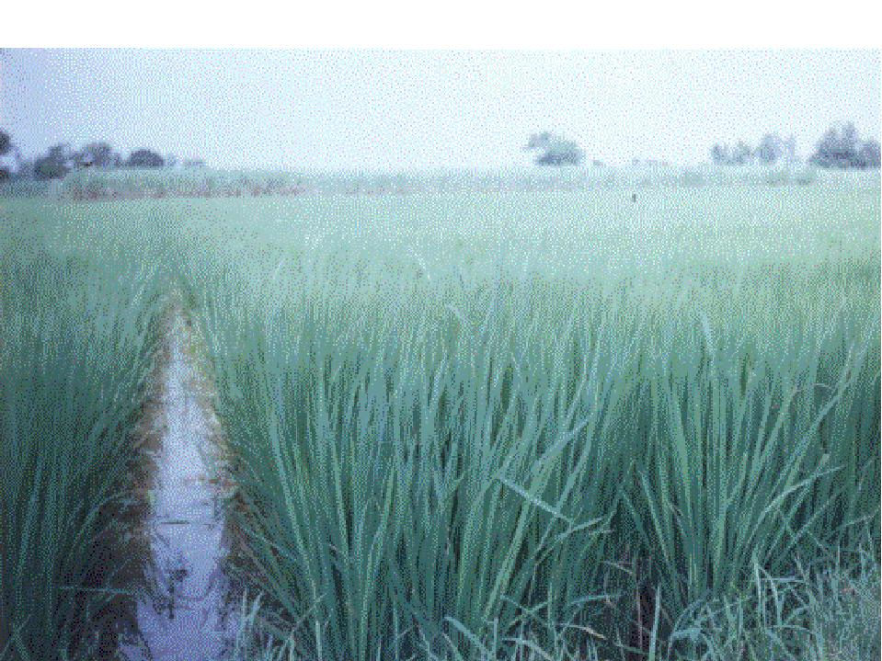

(B) IPM and IPNM:-
Several demonstration, training and exposure visit have been organised to adopt the IPM and IPNM technologies . IPM and IPNM have been promoted in 4674.18 ha land.

(i) Paddy : (NDR-359)
- Total Demonstration conducted 748 in 337.0 ha.
- Average Production 48.0 qt/ha.
- Adoption : No. of Farmers adopted the IPNM & IPM technique =6337
Total Area covered under IPNM &IPM 4674.18 ha.
(ii) Wheat (PBW-343):
- No. of demonstration conducted 748
- Total Area of demonstration –337.00 ha.
- Average production –38.00 qt./ha.
- No. of Farmer adopted the IPNM & IPM technique –5016
- Area expansion under IPNM & IPM in ha. –3517.00
(iii) Maize (Jaunpuri Safed):-
- Total No. of demonstration conducted –81
- Total Area of the demonstration 32.40 ha.
- Average production –40.00 qt/ha.
- Total farmers adopted the IPNM & IPM Technique= 789
- Area expansion under IPNM & IPM 347.00 ha.
(iv) Pea (Azad P-1) :-
- Total demonstration conducted =60
- Area of demonstration =24.00 ha.
- Average production =26.00 qt/ha.
- Total No. of farmers adopted the IPNM & IPM –351.00 ha.
(v) Urd (Type –9) :-
- No. of demonstration conducted –60
- Total demonstration Area –22.50 ha.
- Average production 15 qt/ha.
- No. of farmers adopted the technique –283
- Area expansion under IPNM & IPM –108.15 ha.

C FIELD DAYS:
Field days have been organized to spread the technology among the farmers to adopt the demonstration techniques. Details of organized field days are given below :-
Item | Upto 2006 |  | 2006-09 |  | Cummulative
Item | No. | No of farmers | No. | No of farmers | No. | No of farmers
Zaid  Kharif  Ravi | 80  175  188 | 9750  18190  18950 | 155  103  165 | 17312  11725  17870 | 235  278  353 | 27062  29915  36820
Grand Total |  |  |  |  | 866 | 93797

(D) EXPOSURE VISITS :

It is fact that farmers adopt the technology more by seeing than listening. This institute has always given more emphasis on the exposure visits. The achievements are given below:-

S.No. | Season | Upto 2006 |  | 2006-09 |  | Cummulative
S.No. | Season | No. | No of farmers | No. | No of farmers | No. | No of farmers
2.  3. | Zaid  Kharif  Ravi | 85  175  175 | 1708  4026  4175 | 76  175  181 | 1663  4315  4526 | 161  360  361 | 3571  8521  8701
Grand Total |  |  |  |  |  | 881 | 20743

(E) KISAN MELA / GOSTHI

This institute has wide experience of Kishan Mela/Gosthi organization. This institute organize every year a big Kisan Mela/Gosthi. In the organized Kisan gosthi/mela presence of Agriculture minister, Agriculture Production Commissioner, and other senior I.A.S of U.P.. high lightened the programme. From 2002-07 total 11 programme have been organized in the district Azamgarh and Pratapgarh. The photograph is depicting the success of programme

.
(F). SEED PRODUCTION :-

(i) Wheat (PBW-343):- |  | (ii) Pea (E-6)
- No. of SHGs involve - 105  - Total member involve – 215  - Area – 67.5 ha.  - Production – 108 mt  - Total Profit –5,18,370.00 |  | - No. of SHGs involve –33  - Area in ha. – 17.3  - Production in mt – 34.2  - Profit (in Rs.) – 229425.00
(iii) Paddy (NDR-359)
- No. of SHGs involve –142
- Total No of member involve –347
- Area in ha. –57
- Production in mt –226.4
- Profit in Rs. –10,90,965.00

(G) WOMEN AGRICULTURE EXTENSION PROGRAMME:-

Maximum women are working within the house but not on the field. To utilize the efficiency in agricultural activities on the field, to develop the efficiency/ capacity and also to increase the income of women above women agriculture extension programme was launched in the district Jaunpur by self resources. The highlights of the programme is:-
1. 297 women came out from the house and started the agriculture field work.
2. Total area was covered under the programme is 702 hectare.
3. As cash crop vegetables, vegetable pea, maize pigeon pea are taken.
- Now involved women are self- reliant for the cultivation related activities.

- Horticulture

- - Horticulture Demonstration

Item | Upto 2006 |  | 2006-09 |  | Total
Item | No. | Area (Acre) | No. | Area (Acre) | No. | Area (Acre)
- Vegetable  - Zaid  - Kharif  - Ravi  - Floriculture  - Orchard | 85  85  85  15  35 | 85  85  85  15  35 | 254  254  254  35  108 | 254  254  254  35  108 | 339  339  339  50  143 | 339  339  339  50  143
Total | 305 | 305 | 905 | 905 | 1210 | 1210

B. PROMOTION OF LATEST TECHNOLOGY
(I) LOW TUNNEL POLY HOUSE:-
To grow the healthy and desease free plants, low tunnel ploy house has been promoted and widely used in plant nursery in the district- Jaunpur. This low tunnel poly house secures plants from excess rains and insects attack especially in raining season. As a result, farmers are producing more and healthy plants by using LTPH.. The progress and highlights are given below:
No. of Low Tunnel Poly House 857
No. of Beneficiary 408
Area covered 5999 sq. mtr.

Increase in Income due to Low Tunnel Poly House
Extra Produced plant per bed | Rate per 100 Plant Rs. | Cost of LTPH/Year | Total Extra Income | Extra Profit
1600 | 20.00 | 100.00 | 320.00 | 220.00

(II) ONION STORAGE STRUCTURES:-

Under DASP-U.P. Jaunpur, this institute has promoted an innovative model of Onion storage structure. This model is widely accepted by the farmers. Now the farmers are purchasing the Onion from other states and after 4-6 month of storage, farmers allow to sell and getting 1.5 to 2 times more prices. The achievements are given below:

Onion Storage structures = 146 | No. of Beneficiaries =146

Increase in Income due to storage
Quantity Stored (qt.) | Rate During harvesting (qt.) | Total value of Onion during harvesting | Rate after 6 month storage | Total value of the Stored onion after 6 months | Net profit (in Rs.)
1356.50 | 223.40 | 303042.10 | 456.00 | 639248.00 | 336205.90

(III) ZERO- ENERGY CHAMBER:-
This Zero-energy chamber has been promoted among the vegetable growers. Zero-energy chamber is store for green vegetables. There is no option by which farmers can store their extra green vegetables. Establishment to Zero-energy chambers is very much cost effective and easily acceptable. The progress is given below.

No. of Zero Energy Chamber Established | 52
No. of Farmers Covered | 52

(IV) MACHAN CULTIVATION :-

To get the more yield of vegetable in rainy season, Machan Cultivation has been promoted in the district Jaunpur, Pratapgarh and Azamgarh. The achievements are :-

No. of Machan Cultivation | 1153 | No. of beneficiaries | 1015 | Area | 146.78 ha.

(V) TOMATO- STACKING:-
This technology is widely spread in the district jaunpur due to our intervention 250 farmers have adopted the technique and saving 25% loss in tomato cultivation

Adoption |  |  |  | Staking |  |  |  | Non-Staking
Variety |  |  |  | Total production in qt/ha | Cost of Cultivaton in Rs. in lac | Total Income Rs. In lac | Net profit Rs. in lac | Total production in qt / ha | Cost of cultivation Rs. in Lac | Total Income Rs. in lac | Net profit Rs. in lac | Extra profit Ra in lac.
Variety | Area | No. of Group | No. of member
Rupali | 25.5 | 56 | 182 | 12750.00 | 15.47 | 51.00 | 35.53 | 8925.00 | 9.88 | 31.25 | 21.36 | 14.18

- Bio-farming (Bio compost production and use)

This institute has promoted production and use of Bio-Compost in large scale in the district – Azamgarh, Pratapgarh, and Jaunpur.
(A) Bio-ParK:-
An innovative concept of “BIO-PARK” ( an unit for production of Bio Compost) is given by this institute which is appreciated by the W.B. vice chairman, other World Bank representatives and senior officers of U.P.

The Bio-Park has following details:-
(i.) NEED AND PROBLEM:-
    - Increasing trend of requirement of N.P.K., increasing the cost of cultivation continuously.
    - Deterioration in quality of produce.
    - Bad effect on the health due to consumption of same polluted produce.
    - Bad effect on the environment and Food-Chain. Hence danger on the survival of life.
    - Regular decrease in fertility of soil, may result conversion of land into unfertile land.
    - Imbalanced situations in physical and chemical structure of soil.
    - Decrease in no of friend insects and rational increase in no. of enemy inscts.
    - Increase in new-new infections/ diseases.
    - Maximum expenditure of income is in purchase of medicines.
Keeping in view to solve above need and problems, following objectives are set to establish Bio-Park.
ii. OBJECTIVES:-
- Establishment of Bio-Park for the production of Bio-Compost.
- Increase income through production, use and selling of Bio-Compost.
- Use of bio-compost will increase the fertility of soil and decrease the requirement of chemical fertilizer by which cost of cultivation will be reduced.
- Production of quality produce.
- To increase the fertility of Soil By which increase in production and productivity.
- To conserve and clean the environment and also to maintain the Food-Chain balanced.
- To ensure the availability of vegetables, medicinal plants, fruit plants and flowers side by side .
iii. COMPONENTS OF BIO-PARK:-
1. Nadep Compost
2. Vermi Compost
3. Cow Pat Pit (C.P.P.)
4. Cow Horn manaur (CHM)
5. Tricoderma multiplication
6. Cultivation of medicinal plant and flowers.
7. Establishment of kitchen garden.
iv. ACHIVEMENT OF BIO-PARK:-
- Total 395 (1975 Nadep, Vermi compost and 1975 CPP) Bio-Park have been established in the district Azamgarh and Jaunpur U.P.
- These Bio-Park includes 1975, Nadep Compost, 1975 Vermi Compost and 1975 C.P.P. along with cultivation of medicinal plants, flower and vegetables.
(B). INDIVIDUAL BIO-COMPOST STRUCTURES:-

(i). NADEP COMPOST:- (ii) VERMI COMPOST: (iii). COW PAT PIT (CPP)
No. of Nadep Compost = 5916  No. of Farmers covered = 5173 | No. of Vermi Compost 7812  No. of Farmers covered 5931 | No. of CPP 6713  No. of Farmers covered 6624

- Animal Husbandary

This institute has wide experience of A.H. This institute has established its own A.H. centre. For the purpose of demonstration and training centre.The achievements of A.H. Sector in given below:
- Under the U.P. Sodic Land Reclamation project 411 Animal Husbandry animators have been developed.
- Under the DASP U.P. and UPSLRP. 36 training and 12 exposure visits have been organized.
- 39 health care camps have been organized.
- Total 26 goat keeping, 11 milk production, 15 Piggery and 32 Poultry units have been established by the farmers in Jaunpur, pratapgarh and Banda district

- Fisheries
To increase the income of farmers to make the use of rural ponds and to harvest the rain water several efforts have been done by this institute. The progress and highlights are given below :
- This institute has established its own demonstration ponds in the area 1.25 hectare.
- This institute has imparted training regarding fisheries, Water harvesting and conservation to the 327 farmers upto march 2006.
- 156 farmers have been adopted the practices in the 124 hectare ponds.
- Increase in the water table has been observed upto 1 meter.
- Extra income of the farmers have been generated through the irrigation and fisheries.
- Under the Water Shed Development Project in the district Balrampur Water Harvesting and Conservation Programme have been completed in 4000 ha area.
6. Agriculture & Its Allied Activities Related Completed and Ongoing Projects:
S. No. | Name of Project | Funding Agency (Name, Address & E.mail) | Start and End year | Received amount
i. | UP Diversified agriculture support project-I Jaunpur. | UP Diversified agriculture support project  4th, Floor, Picup Bhawan, Bibhuti Khand, Gomti Nagar, Lucknow-226010  E.mail: dasppcu@saytam.net.in | 2000-05 | 9908048.00
ii. | UP Diversified agriculture support project-II Sultanpur | UP Diversified agriculture support project  4th, Floor, Picup Bhawan, Bibhuti Khand, Gomti Nagar, Lucknow-226010  E.mail: dasppcu@saytam.net.in | 2008 To onward | 191400.00
iii. | Extension Service & Mobilization and Participation of farming Communities | UP Diversified agriculture support project 4th, Floor, Picup Bhawan, Bibhuti Khand, Gomti Nagar, Lucknow-226010E.mail : dasppcu@saytam.net.in | 2001-03 | 1882653.00
iv. | UP Sodic land Reclamation project, phase-I Pratapgarh. | UP. Bhumi Sudhar Nigam, Bhumitra Bhavan TC-19/B Vibhutikhand, Gomtinagar, Lucknow-226010 E.mail No: upbsnapplication@in.com | 1994-99 | 14740000.00
v. | UP Sodic Land Reclamation project Phase-II Pratapgarh. | UP. Bhumi Sudhar Nigam, Bhumitra Bhavan TC-19/B Vibhutikhand, Gomtinagar, Lucknow-226010  E.mail No: upbsnapplication@in.com | 1999-07 | 11112000.00
vi. | Rastriya Sam Vikas Yojna- Azamgarh. | Govt. of India/DRDA Azamgarh | 2005 Onward | 9604325.00
vii. | UP Water Sector Restructuring Project Jaunpur. | Deptt. Of Irrigation/W.B. SSK-36 Jaunpur. | 2004 To onward | 10235076.00
viii. | UPWSRP Baharaich | Deptt. Of Irrigation/W.B. SNK-3 Baharaich. | 2004-06 | 1750980.00
ix. | National Horticulture Mission-Balia Kaushambi & Barabanki. | Deppt. of horticulture Balia, Kaushambi & Barabanki. | 2007 to Onwards | 1229037.00
x. | Kishan Vidyalay Yojna | Deppt. of Agriculture of 11 districts of U.P. | 2007 Onward | 593543.00
xi. | ATMA Pratapgarh, Sultanpur. | Deptt. Of Agriculture Pratapgarh and Sultanpur. | 2007 to onward | 32500.00
xii. | UP WSRP/ WALMI | U.P. Water and Land Management Institute Utretia-Lucknow. | 2004-06 | 3425774.00
xiii. | Pratapgarh Pilot sub Project under UP SLRP regarding water and Land Management | UP. Bhumi Sudhar Nigam,  Bhumitra Bhavan, TC-19-B, Vibhutikhand, Gomtinagar, Lucknow-226010  E.mail No: upbsnapplication@in.com | 1998-01 | 290000.00
xiv. | Privatization of extension services Aspur Devsara-Pratapgarh | UP Bhumi Shudhar Nigam TC-19/B Bibhuti Khand Gomtinagar Lucknow-220610 E.mail: upbsnapplication@in.com | 2001-02 | 330000.00
xv. | Watershed Development Programme-Balrampur | NABARD  Halwasia Hajratganj Lucknow. | 2002-03 | 57000.00

